厦门迪太进出口有限公司
XIAMEN DITAI IMP.& EXP. CO.,LTD
地址：中国厦门禾祥西路鸿升大厦8A
8FL, Hongsheng Building, West Hexiang Road, Xiamen, Fujian, China
TEL:0592-26808108 Phone:+8615160094689 FAX:0592-2680880 E-mail: hana.zhuang@xmditai.com
----------------------------------------------------------------------------------------------------------------------

Potassium Hydrogen Oxalate CAS 127-95-7 with Best Price
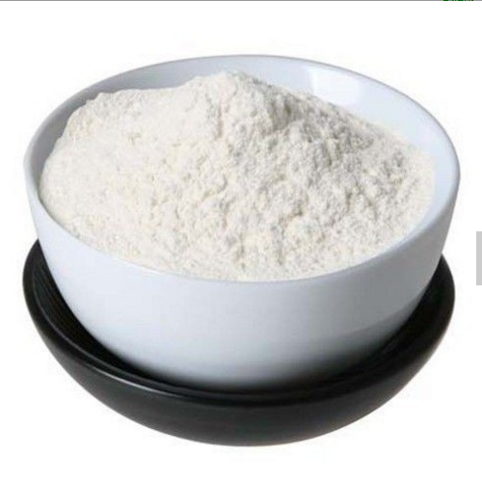
- Product description
Chemical Name：Potassium Hydrogen Oxalate
Other Name：Potassium Binoxalate ; Potassium acid oxalate ;PBO
CAS NO.: 127-95-7
EINECS No.: 204-873-0
FORMULA WT:128.12
FORMULA: C2HKO4
Appearance:White crystal
Package:25kg net in woven bags

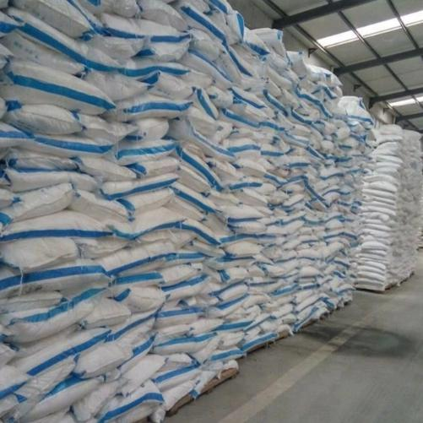
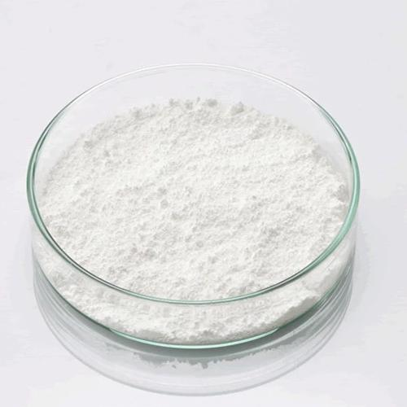
2.Specification
Property | Specification | Results
Appearance | White Crystal | white crystal
Assay | ≥99.0% | 99.35%
Insoluble matter | ≤0.02% | 0.004%
Sulphate（SO4） | ≤0.02% | ＜0.02%
Chloride(Cl) | ≤0.005% | ＜0.005%
Iron（Fe） | ≤0.002% | ＜0.002%
Heavy Metals（as Pb） | ≤0.001% | ＜0.001%
Conclusion: Conform to the CP standard

3.Application
- Marble & Granite Industry : Use for Marble & Granite polishing
- Environmental Coatings : Use for environmental Coatings manufacture
- Metal industry: Use for metal polishing and rust cleaning
- Chemical reagent: Use for chemical reagent

- Company Information
Xiamen Ditai Chemicals Co., Ltd is a professional chemical company in China. Specializing deal and export various kinds of quality chemicals since 1997. The products Include industry chemical, Animal feed additive, Food additive, Agrochemical, Fertilizer, pharmaceuticals, water treatment and Minerals. Our management team has over 17 years of combined expertise meeting the needs of clients. We are proud our quality chemcials and service was approbated by the clients in the worldwide.
Xiamen Ditai Chemicals Co., Ltd is an ISO9001:2008 certificated organization. We alway pay attention to the quality control. For us, quality means satisfied clients. Only by constantly improving our internal and external procedures are we able to remain a reliable supplier of chemicals for our clients worldwide. Every step of the distribution chain is constantly checked and rechecked to guarantee the quality. Through continuous improvement in quality and service, we will provide our customers with products of optimum quality consistent with their requirements.
Besides the quality, we think the competitive price of goods is also important. Our comprehensive distribution network, buying power and efficient inventory management system allow us to offer our products at the best possible prices. Our principle is: Quality Chemicals With Competitive Prices - We Supply!
Up to now many of our chemicals have been done REACH final registration. It is convenient for the clients to use our chemicals in Europe market.
Your satisfaction is our most interested thing. Also your any suggestion will be highly welcome by us. Now enjoy your visiting and hope to hearing from you!

Best Regards
Hana Zhuang
-----------------------------------
Xiamen Ditai Chemicals Co., Ltd.
8fl, hongsheng building,
west hexiang road, Xiamen, China.
Web: www.xmditaichem.com

